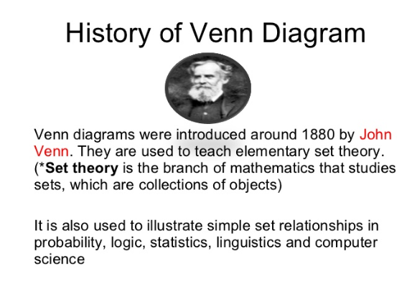

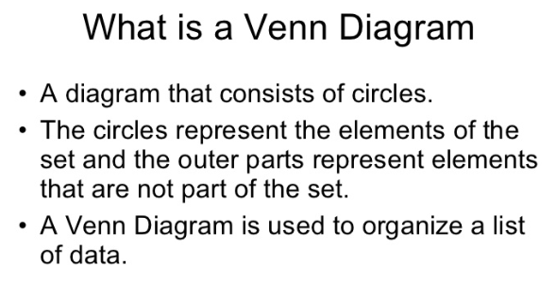
A Venn diagram is an illustration of the relationships between and among sets, groups of objects that share something in common. Usually, Venn diagrams are used to depict set intersections (denoted by an upside-down letter U). This type of diagram is used in scientific and engineering presentations, in theoretical mathematics, in computer applications, and in statistics.

